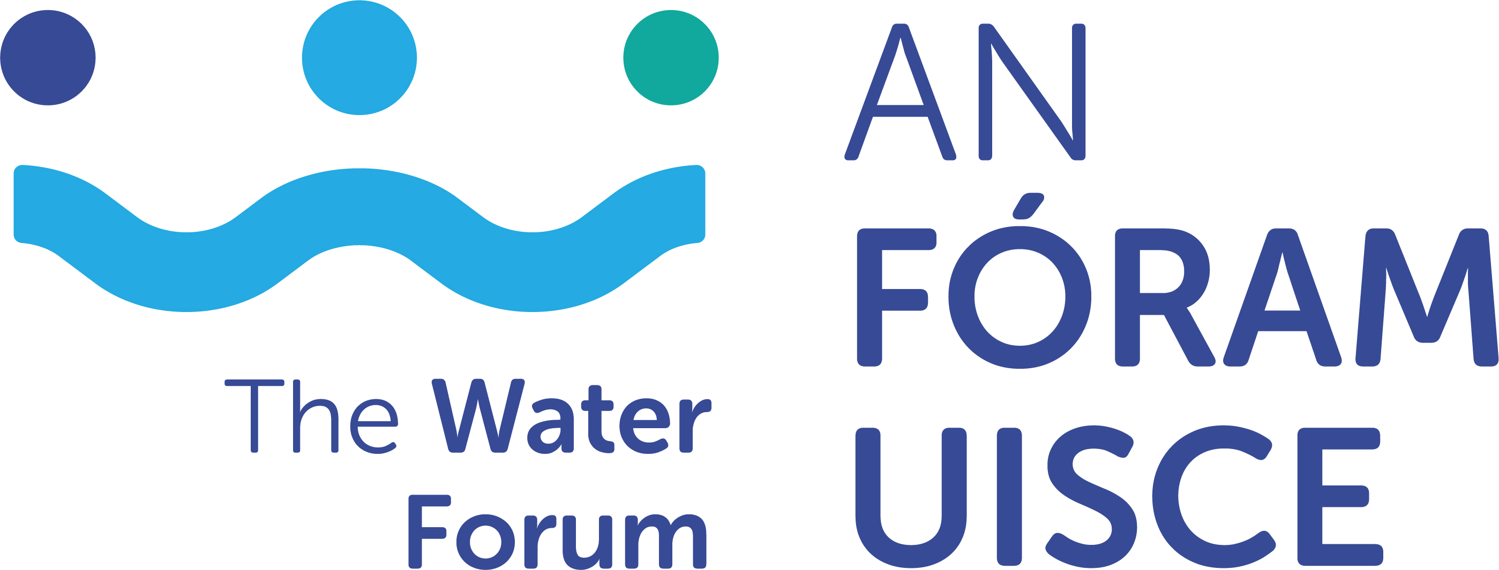

Request for Research Tender on
Non-domestic water use; learnings from international data and conservation initiatives

APPLICATION FORM
Application Form Guidelines
- All sections must be answered.
- Please ensure your application has been signed by all parties.
- Please read in full, the terms and conditions for this application before submission.
- All queries should be directed to Dr Triona McGrath by email to triona@nationalwaterforum.ie
- All completed applications should be submitted electronically to triona@nationalwaterforum.ie by 5pm 15th September 2022
6: Late or incomplete applications will be deemed ineligible. This will be
strictly enforced.

- Lead Researcher

Name
Organisation/Education Institution
Research Centre
Email
Telephone
Position

- Please attach updated CV of lead Researcher incorporating the following as appropriate; education, experience and/or details of research and published works.
- Please attach updated CV of Supervisor of Researcher, where applicable if the lead Researcher is postgraduate or postdoctoral researcher, incorporating the following; education, experience and/or details of research and published works.

- Project Proposal

Project Title | Non-domestic water use; learnings from international data and conservation initiatives
Total Project Cost
Proposal description which demonstrates a clear understanding of the brief and requirements of the project
(1500 words maximum)
Project management arrangements
(500 words maximum)
Timeline incorporating deliverables and Gantt chart
(500 words maximum)
Proposed Budget and justification
(500 words maximum)

Institutional Sign Off

Lead investigator | Name:  Signature:  Date:
Research Office or equivalent | Name:  Signature:  Date:

