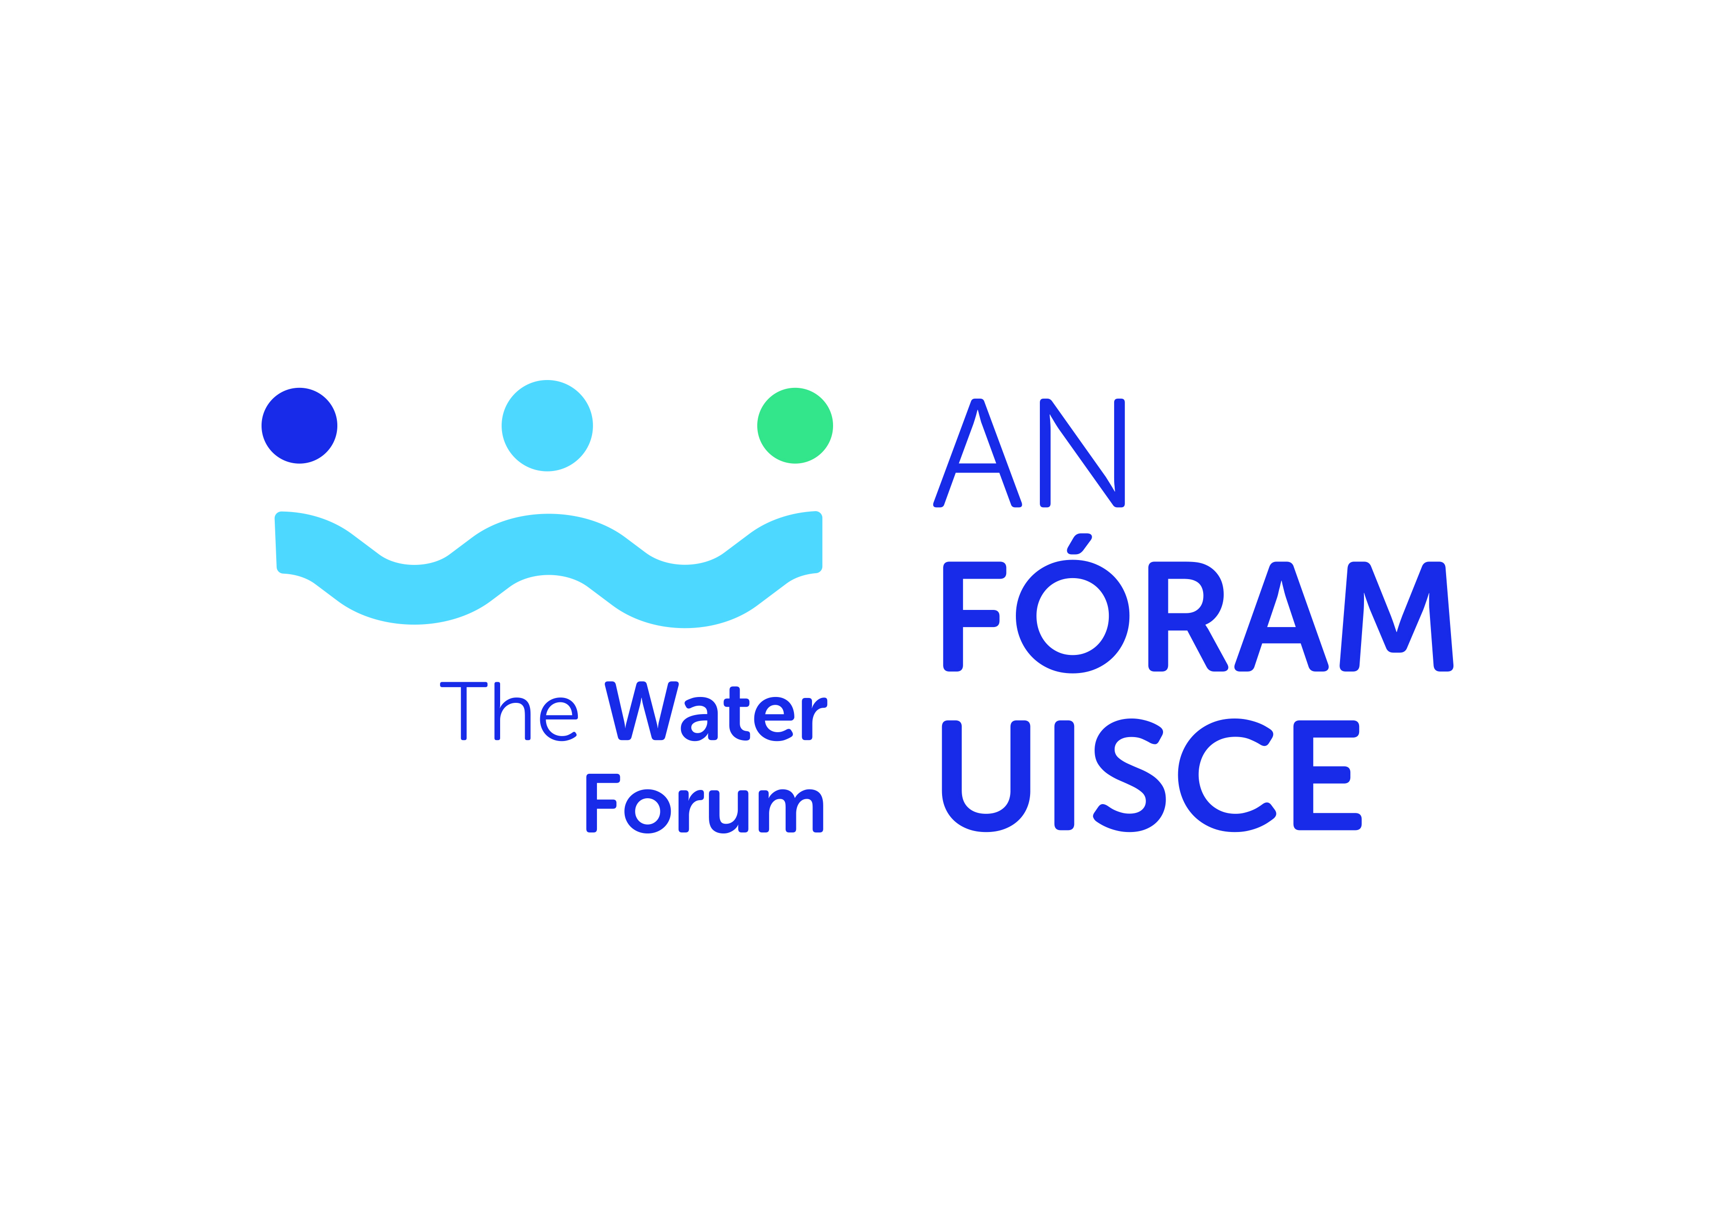

Request for Research Tender on
An assessment of policy coherence and conflicts for water and environmental management

APPLICATION FORM
Application Form Guidelines
- All sections must be answered.
- Please ensure your application has been signed by all parties
- Please read in full, the terms and conditions for this application before submission
- All queries should be directed to Dr Triona McGrath by email to triona@nationalwaterforum.ie
- All completed applications should be submitted electronically to triona@nationalwaterforum.ie by 1700 Monday 6th September 2021.
6: Late or incomplete applications will be deemed ineligible. This will be
strictly enforced.

- Lead Investigator Details

Please attach updated CV (max 4 pages) incorporating the following as appropriate: education, experience and/or details of research and published works. (40 marks allocated to track record of research lead/team).

Name
Organisation/Education institution
Research Centre/Group (if applicable)

Email
Telephone
Position

2. Project Proposal

Project Title | An assessment of policy coherence and conflicts for water and environmental management
Total Project Cost
Proposal description which demonstrates a clear understanding of the brief and requirements of the project (30 marks)
(1000 words maximum)
Project management arrangements (10 marks)
(250 words maximum)
Timeline incorporating deliverables and Gantt chart (10 marks)
(250 words maximum)
Proposed Budget and justification (10 marks)
(250 words maximum)

Institutional Sign Off

Lead investigator | Name:  Signature:  Date:
Research Office or equivalent | Name:  Signature:  Date:

