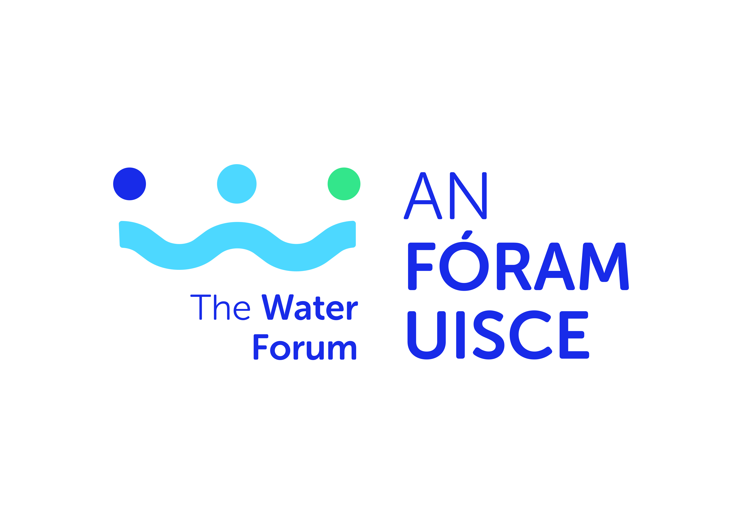
Minutes
Meeting held on the 30th October 2019 at 10.30 am.
Attendees: Tom Collins (Chair), Connie Rochford, Keith Hyland, Denis Drennan, Thomas Cooney, Derrie Dillon, Dominic Cronin, Bernadette Connolly, Sinead O’Brien, Thomas Harrington, Martin McEnroe, Tim Butter, Brendan Fitzsimons, Tim Fenn, Liam Berney, Neil Walker, Suzanne Linnane, David Wright, Gerald Quain.

Apologies: Barry Deane, Joe Gallagher, Charles Stanley Smith, Elaine McGoff, Laurie Kearon and Ollan Herr

In attendance: Gretta McCarron, Donal Daly and Sharon Kennedy

Item | Details | Summary | Action
1.1 | Welcome | Tom Collins welcomed the members to the meeting and thanked all for their attendance.  Apologies were noted.
1.2  1.3 | Consideration of draft minutes of meeting held on the 3rd September 2019.  Issues arising | Draft minutes were noted and approved.  There were no issues arising which were not included on the agenda. | Noted
2 | 2.1 Budget  Staffing arrangements | The budget status for 2019 was noted. It was noted that it was not possible to undertake the full range of activities during the year due to the delay in recruitment but that 2020 should see a significant increase in activity and associated expenditure.  A discussion took place with regard to projects to commence this year and an outline of projects for 2020.  The members referred to the post of Water Services/Catchment Management Lead which has not yet been filled. Following consideration of same, it was agreed to reconvene the sub-group comprised of David Wright, Suzanne Linnane, Charles Stanley Smith, Sinead O’Brien and Liam Berney to review the job description and duties for the post and to bring forward recommendations at the December meeting.  A further discussion took place with regard to Sharon Kennedy’s departure and the filling of the post of SEO. Tom Collins advised that he had met with the sub-group who had considered the various options available to An Fóram at this point in time and having regard to the fact that An Fóram is not currently empowered to recruit its own staff. Tom further advised that he had met Mr. Eamonn Waters, DHPLG to discuss this matter. It is understood that statutory authority may be conferred to An Fóram in due course in relation to employment. Tom also met with Mr. Joe MacGrath, Chief Executive with Tipperary County Council who confirmed that TCC is willing to continue to facilitate An Fóram in relation to the post pending the passing of the relevant legislation. Having regard to the various options and considerations, it was agreed by the sub-group to recommend the appointment of Mr. Donal Purcell, A/SEO with TCC to the post with An Fóram for a period of not less than one year. This will facilitate the passing of the required legislation and the recruitment of staff to An Fóram in due course.  It was agreed to formally thank Tipperary County Council for their continued support in terms of employment arrangements for An Fóram. | Noted  Agreed  Agenda item for the December meeting.
3.1 | Symposium | Gretta McCarron presented to the members on the plans for the Symposium:  It was noted that the theme for this year’s symposium is ‘Water Quality in Ireland: Re-imagining the future’  A number of further suggestions in terms of the programme, speakers and topics were made and it was agreed to incorporate same. The sub-group will be re-convened to further consider arrangements and finalise same.  A further update will be provided at the December meeting. | Noted  Agenda item for December meeting.
4 | Updates from Standing Committees | 4.1 Water Services Standing Committee  An Fóram’s submission to the CRU on Irish Water’s RC3 for 2020 to 2024 was noted.  4.2 Catchment Management Standing Committee  Summary of meeting held on the 24th September was noted.  Letter issued to DHPLG regarding Climate Action was noted.  4.3 Proposals for committees  Tom Collins referred to an issue which arose at the last meeting of the Catchment Management Standing Committee with regard to the possibility of amalgamating the work of that committee and the Water Services Standing Committee to form a single Committee. A further proposal emerged in relation to creating a liaison working group between the members of An Fóram and the staff to support and develop the implementation of the strategic plan  The members considered the proposals and following a lengthy discussion agreed that the two committees should continue and that their work programmes be strengthened to reflect the requirements of the Strategic Plan and further to become more proactive in terms of its oversight and monitoring roles.  It was agreed to proceed accordingly and to commence work on developing a work programme for both committees. Next meetings of both committees to take place on the 13th November 2019.  The members then considered recent issues arising from operational issues associated with the Leixlip Water Treatment Plant which resulted in a ‘boil water notice’ being issued to over 600,000 consumers in the Greater Dublin Area.  It was noted that such difficulties are being experienced through the country on an on-going basis.  It was noted that Irish Water representatives are to attend the December meeting. It was agreed to issue a letter to Irish Water, requesting that specific issues be addressed at the meeting including:  - The Leixlip plant outage;  - Boil Water Notices;  - Progress in relation to their work programmes;  - Issues arising from the recently published report of the Water Advisory Body.  - Developing a formal protocol in relation to information and consultation with An Fóram.
5 | Implementation of AFU Strategic Plan | It was agreed to place the following items on the agenda for the two committee meetings on the 13th November i.e.  - Redevelopment of the website;  - Strategic Plan;  - Draft Communications Strategy;  - Draft Education and Awareness Strategy and;  - Draft Research Strategy.  Reports in relation to same can be placed on the agenda for the plenary meeting in December. | Agenda item for next meetings of the water services standing committee and the catchment management standing committee.  Report to plenary meeting in December.
6 | CAP Reform | It was agreed to place this as an item on the agenda for the Catchment Management Standing Committee in November | Agreed.
7 | AOB | A discussion took place with regard to invitations issued by the Department in relation to a consultation process regarding the Significant Water Management Issues to be held in November. It was agreed to request further place for members of An Fóram and to extend the attendances in order to facilitate further engagement.  A presentation was made to Sharon Kennedy who was thanked for her work with An Fóram. Sharon was wished well in her new appointment. Sharon thanked the Chair and the Members for their co-operation and support and wished An Fóram continued success. | Agreed
8 | Next meetings | Nov 13th  Catchment Management Standing Committee meeting in the morning and  Water Services Standing Committee meeting in the afternoon.  Dec 3rd  plenary meeting of An Fóram

Signed: Dr. Tom Collins Chair

